INSTRUCTIONS FOR THE PREPARATION AND SUBMISSION OF PAPERS
 | 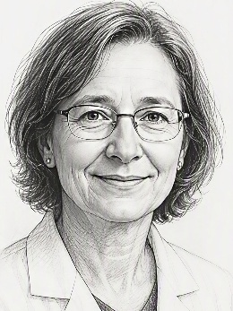  AI-Generated | 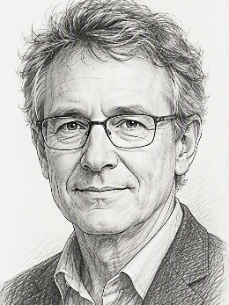  AI-Generated | 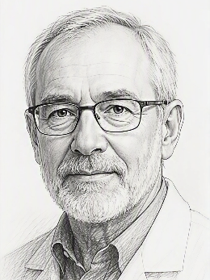  AI-Generated
 | A. SURNAME  University of Figueres, Spain.  Graduate of Madrid Surrealist Vehicle Engineering College, 1992. Currently director of marketing at Virtual Data Plc. | B. SURNAME  Logistics Smiling Authority of Gioconda University, Italy  Obtained B.E. with Prof. Va Dinci at Firenze University, and M.Sc. from Leonardo College | C. SURNAME  Night Watch Control Engineering Company, Amsterdam, The Netherlands.  Obtained his PhD from the Dutch University of High-Capacity Vehicle Art.
Abstract
This paper provides instructions for preparing an extended abstract to be presented at ICWIM10/HVTT19 – Moving Forward Together conference. This is a joint international scientific event hosted by the International Society for Weigh-In-Motion (ISWIM) and the International Forum for Heavy Vehicle Transport & Technology (HVTT Forum) in Ljubljana, Slovenia, from May 9 to 13, 2026. Authors wishing to submit a full-length paper should use the provided Elsevier template instead.
Abstracts should be between 150 and 200 words in length and must be provided in English. Papers may be end-user or academic in focus but must remain free of commercial content.
Keywords: Language, Font, Photograph, Heavy Vehicles, Freight Transport, WIM, Symposium (maximum 12 keywords)

Paper Parts
Format the paper strictly with the provided styles. Use the keyboard shortcuts (in blue) where available; body text must use Normal style (shortcut Ctrl+Shift+N). Do not insert empty lines or paragraphs between paragraphs!

General Instructions

Publishing Options & Templates
Authors may choose to submit either a full-length paper or an extended abstract. This template is for extended abstracts only. Authors wishing to submit a full-length paper should use the Elsevier template instead. Authors should select the route most appropriate to the scope and maturity of their work. Refer to Table 1 for details.
Table 1. Overview of publishing options
 | Full paper | Extended abstract
Format | Full-length research paper (6-10 pages) | Extended abstract with a more practice-focused emphasis (3-6 pages)
Template | Elsevier paper template | Extended abstract template
Review process | Reviewed by at least two reviewers, with a more thorough assessment against academic research-publication standards | Reviewed by two reviewers, with the emphasis primarily on technical content, relevance and quality
Publication route | Formal Elsevier conference proceedings, indexed in major academic databases | Separate extended abstract proceedings, published in an established repository, such as Zenodo
Open Access | Yes | Yes
Publication timing | Expected to be available approximately two months after the conference | Expected to be available at the time of the conference if all Rights and Access forms are received in time. Otherwise, a draft version will be provided.
Best suited to | Mature research suitable for formal academic publication, giving papers greater visibility and citation potential | Technical findings, applied work, case studies, preliminary results or contributions that do not require a full research paper
Submissions that do not follow the appropriate template and instructions may be rejected regardless of the quality of their content. The editors reserve the right to make minor editorial changes without consultation; any substantive changes will be made only with the authors’ approval.

Submission Format
Submit papers electronically in both PDF and DOCX formats, with all images placed within the text.

Length
The extended abstract (including the cover page, figures, photos, and reference list) must be between 3 and 6 pages, including the title page.

Language
All papers must be submitted in English.

Document Style
Authors are required to use this template and to strictly follow the instructions.

Margins
Use a top margin of 3.25 cm and bottom, left, and right margins of 2.0 cm on A4-size pages (210 x 297 mm).

Typeface
Use 11-point Times New Roman with Normal style (Ctrl+Shift+N) and 1.15 line spacing. Author biographies and other special paragraphs follow the specific formats defined in this template.

Headings
Number first- and second-level sections as 1., 2., etc. and 1.1, 1.2, etc.; leave third-level sections unnumbered, with bold italic titles. Capitalise all main words except articles and prepositions. Use Ctrl+Shift+1, Ctrl+Shift+2, and Ctrl+Shift+3 for correct heading formatting and numbering.

Section Spacing
Do not add extra spacing or empty paragraphs; all spacing is controlled by the defined styles.

Headers and Footers
Header with the authors’ names and paper title (in bold) are formatted with Paper Header style. Retain page numbers in the footer; their format may be adapted later.

Title Page
The title page includes only the paper title, author details and photos, abstract, and keywords.

Title
The paper title should be centred in 12-point Times New Roman bold capital letters like the title of this document (Heading 1 style, Ctrl+Shift+T).

Author Information
Compulsory author(s) information includes:
- 3×4 cm photo(s), minimum 300 dpi resolution;
- each author’s initial and surname (Author style, Ctrl+Shift+A);
- short affiliation, including country (Author Affiliation style, Ctrl+Shift+Z);
- short, up to 2-sentence CV (Author CV style, Ctrl+Shift+V).
An example is provided on the first page of this document.
If there are more than five authors, omit the photos and use the available cells for additional author details.

Abstract
The abstract should be no more than twelve lines or 200 words. Keywords should also be provided beneath the abstract. The abstract title is formatted with Abstract heading style (Ctrl+Shift+H), which inserts a line before it. Format the abstract text with Normal style (Ctrl+Shift+N).
The entire title page must fit on page 1!

Figures, Tables, and Equations
Number all figures, tables, and equations consecutively by type and cite them in the text, e.g., Figure 1, Table 1, Equation (1). Place each item as close as possible to its first reference, and do not abbreviate “figure,” “table,” or “equation.”

Figures
Figures include illustrations, photographs, charts, and graphs, all with captions. Insert captions via References/Insert Caption/Figure to apply automatic numbering. Figure Caption style (Ctrl+Shift+C) will be applied automatically. Alternatively, copy an existing caption, edit it, and press F9 to update numbering.
Figures should not float but be in line with text (right click/Wrap Text/In line with Text). The paragraph with the figure must be formatted with the Figure style (Ctrl+Shift+F).
All writing within figures should, where possible, be in 8- to 10-point Times New Roman.
If a figure was generated using AI, state this clearly in the caption.
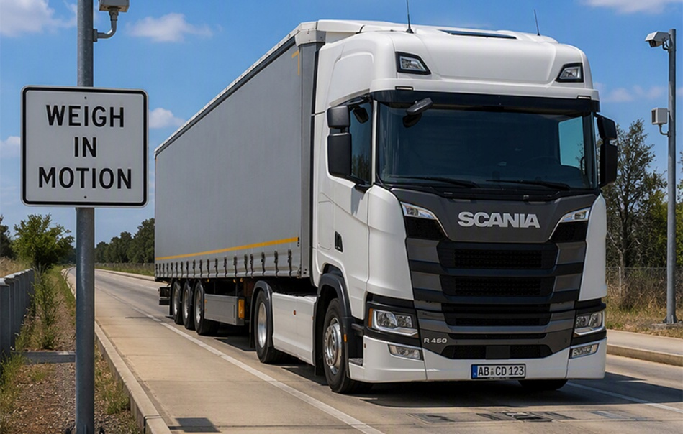
Figure 1. This is a sample figure caption (AI-generated)

Tables
Table captions should be above the table, flush left. They are automatically numbered if inserted with References/Insert Caption/Table, but the Table Caption style (Ctrl+Shift+T) must then be applied manually. Alternatively, copy an existing table caption, edit it, and press F9 to update numbering.
Table 2. This is a sample table caption
 | Type 1 |  | Type 4 |  | Type 5
 | Gross | Axle | Gross | Axle | Gross | Axle
Mean IF | 1.00 | 0.98 | 1.03 | 1.03 | 1.02 | 1.02
COV (%) | 7.21 | 9.86 | 6.21 | 8.44 | 5.18 | 7.85
Within 15% | ----- | 93 | ----- | 94 | ----- | 85
Format table cells with Table Text style (Ctrl+Shift+X), left-aligned, in 10-point text. Do not use vertical lines; use 0.5-line borders only at the top, bottom, and between headers and data. Set 12 pt spacing before the paragraph following the table.

Equations and Units
All equations should be indented 1 cm from the left margin (style Equation, Ctrl+Shift+E) and numbered in brackets in the extreme right-hand side of the margin as follows:
$$C=\frac{\sum_{i}{n_{i}}}{\sum_{i,k}{\left(\frac{W_{ik}^{d}}{W_{i}^{s}}\right)}}$$ | (1)
Use the 2-cell table as in this example, without any other text in the equation cell; otherwise, Word may automatically reduce the font size. References/Insert Caption/Equation will insert a paragraph with an equation number that should be moved into the table and formatted with style Normal (Ctrl+Shift+N).
Alternatively, copy the 2-cell table to the new location and replace the equation. Press F9 to refresh the equation number.

Units
SI system must be used for the units. Use a decimal point, not a comma.

Photographs and other graphics
Photographs should be at least 300 dpi; resolutions above 600 dpi only increase file size. Use high-quality JPG compression but keep each image below 1 MB. Resize photos to their final dimensions in a photo editor before importing them into Word.
For graphics other than photos, use PNG to preserve sharp lines, text, and solid colours without compression artefacts. Apply the same resizing rules as for JPG photographs.

List of references
Provide a list of references at the end of the paper in the Harvard Cite Them Right (author-date) referencing style. In the body text, cite references by author and year, as in the following examples: “Jones and Smith (1996) have extended the theory to in-motion systems” or “the theory for pseudo-static systems is well established (Kessler, 1995).”
The reference list style should be as in section 8, in alphabetical order (first author’s last name), formatted with References style (Ctrl-Shift-R).
All listed references must be referenced in the text.

Acknowledgement
This section is not mandatory. For example, the authors thank the Agency XX for the funding and support for this research work, and Mr./Mrs. YY for his/her fruitful advice.

Declaration of AI use in the manuscript preparation process
The use of AI tools in the manuscript preparation process must be declared by adding a statement here. The statement will appear in the published work. Delete this section if not applicable. We have adopted Elsevier’s AI use policy; for more information, please refer to Elsevier’s Guide for Authors (https://www.sciencedirect.com/journal/transportation-research-procedia/publish/guide-for-authors#ethics-and-policies-declaration-of-generative-ai-use).

References
Freud, S.J., Smith, A.W. and Mannion, A.N. (1992) ‘A new approach to behaviourism’, Journal of Structural Engineering, 12, pp. 1463–1479.
Jones, J.M. (1992) Elements of WIM systems in operation. E & F-N Spon.
O’Brien, E.J. and Sclob, J.M. (1993) ‘Prediction of extreme load effects in highway bridges’, in O’Reilly, A.M. and Smith, J.V. (eds.) Proceedings of the 9th International Conference on Highway Structures, Warsaw, Poland, 14–16 September 1993. London: International Association for Structural Engineering, pp. 131–143.
O’Connor, W.D., Bloggs, J. and Smith, J.J. (1994) ‘A proposed renewable energy source’, in Jones, A.B. and Smith, J.J. (eds.) Proceedings of the 2nd International Congress on Innovation, Amsterdam, Netherlands, 6–8 June 1994. Amsterdam: Elsevier, vol. 2, pp. 121–130.
Zeghal, M. (2009) ‘The impact of grain crushing on road performance’, Geotechnical and Geological Engineering, 27(4), pp. 549–558.

